


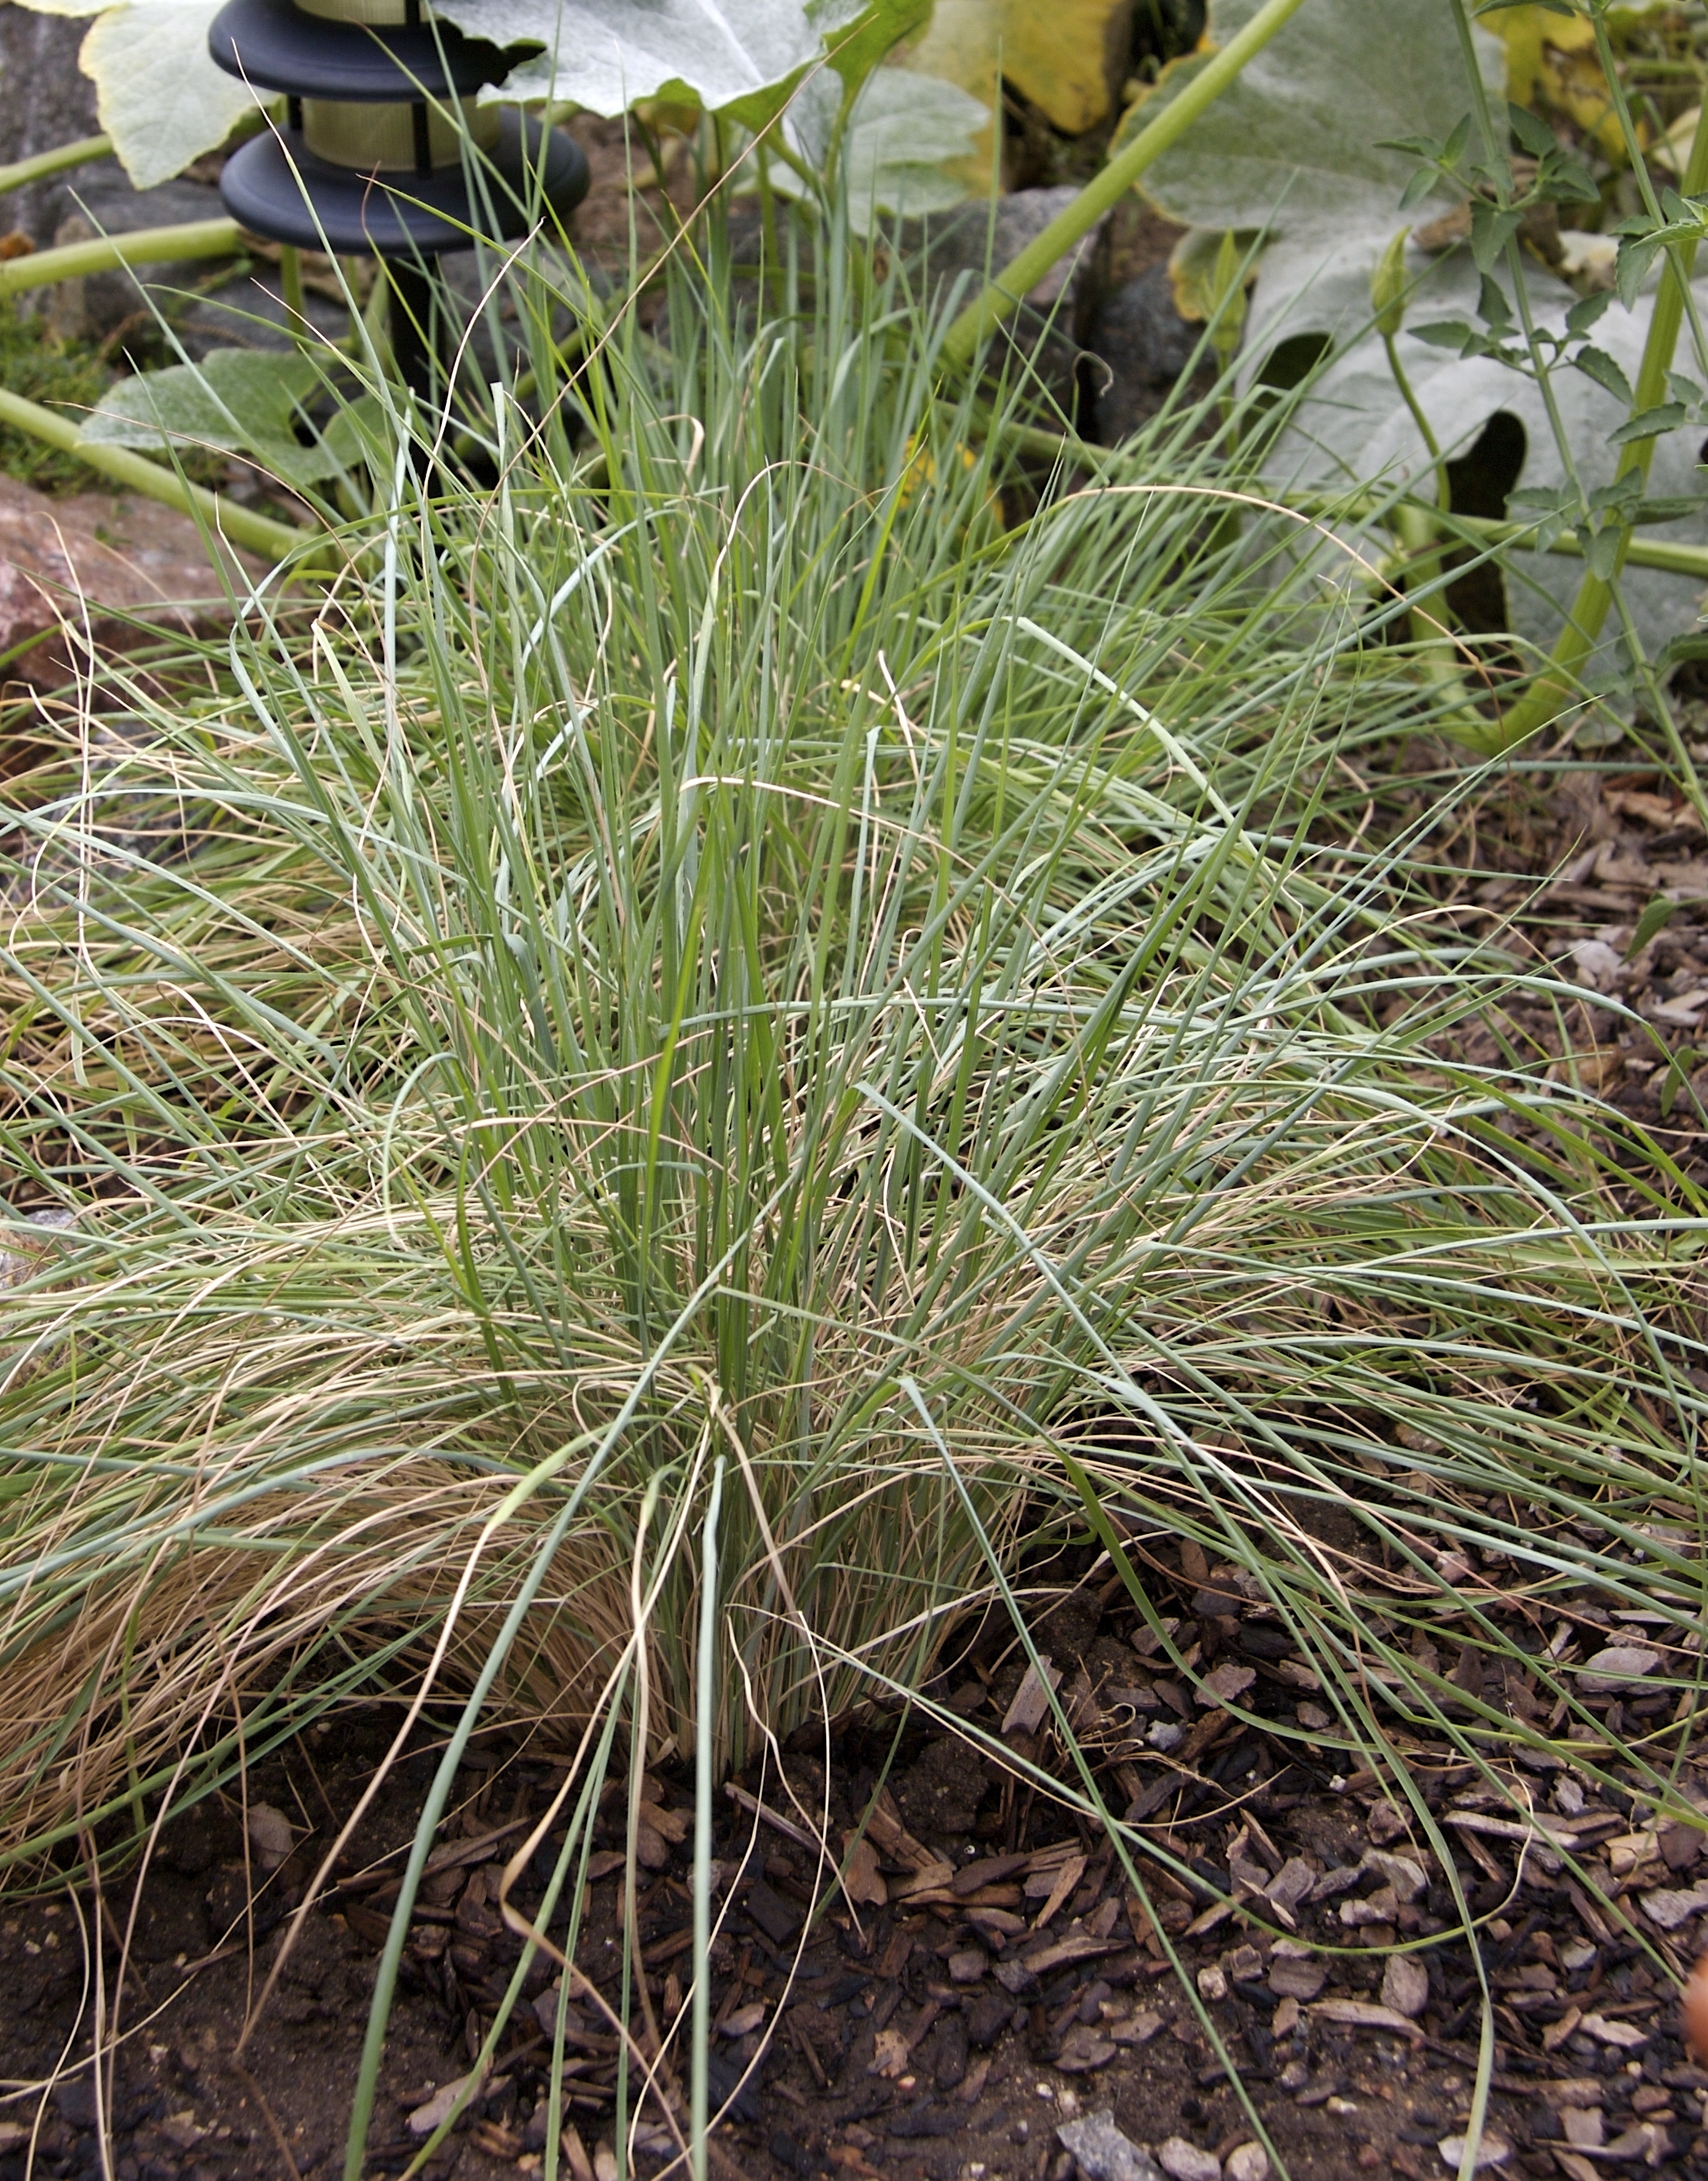

Height: 20-24”
Width: 12-15”
Blooms: August to September
Sun: Full sun to partial shade
Water: Moderate
Hardiness: USDA zones 4-6
Culture: Ordinary soil
Introduced: 1998
Annual
Many gardeners consider the shimmering heads of bright ruby and silver flowers the most beautiful new contribution to bedding or the border. It sparkles like champagne bubbles.

Pink Crystals® Ruby Grass
Melinis nerviglumis
www.plantselect.org

