

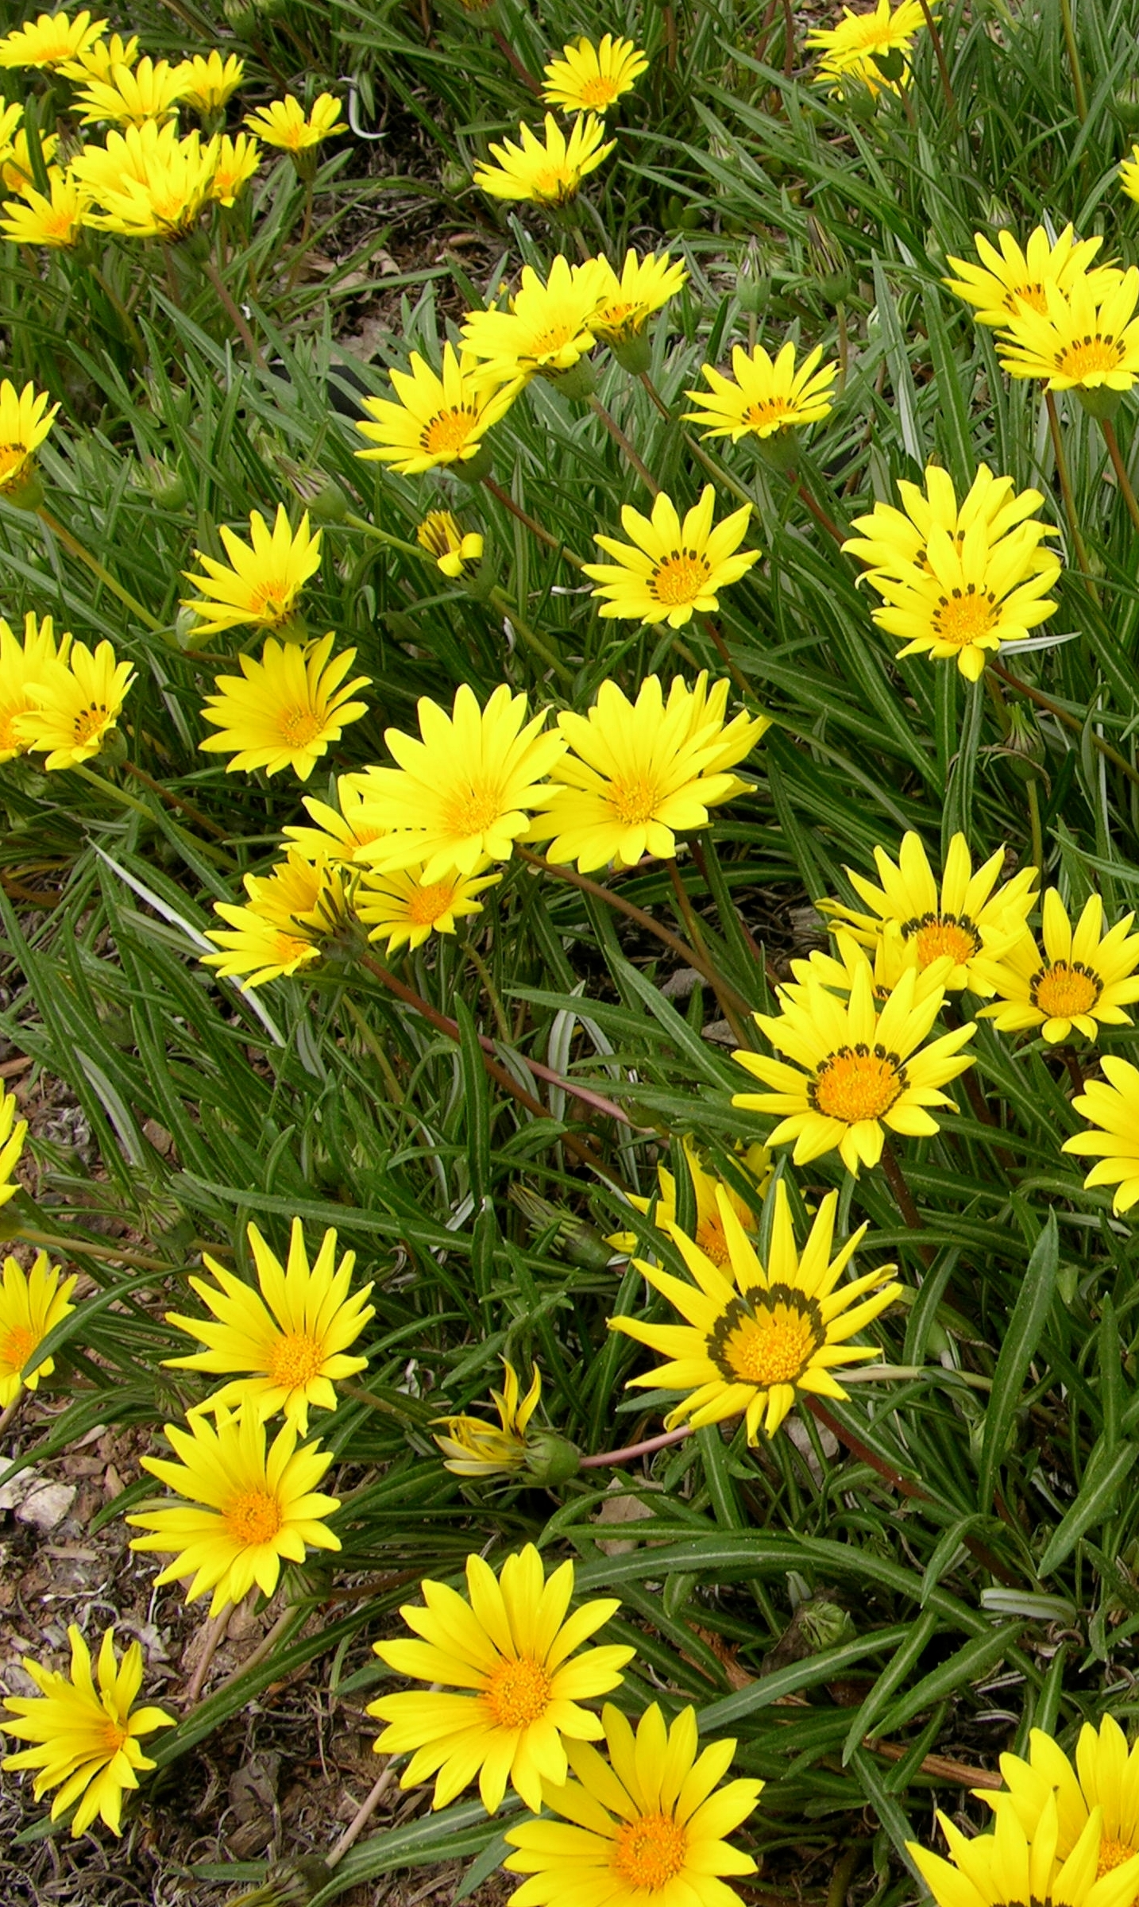

Height: 8-12”
Width: 10”
Blooms: June to frost
Sun: Full sun to partial shade
Water: Moderate to dry
Hardiness: USDA zones 4-8
Culture: Loam; light fertilizing in sandy soil
Introduced: 1998
Perennial
This plant has glossy mounds of deep green, strap-shaped leaves with three-inch shiny yellow flowers throughout the season. This selection is cold hardy compared to the annual bedding gazanias. It does well under ordinary garden treatment, or in unamended, dry soils (once established).

Colorado Gold® Gazania
Gazania linearis
www.plantselect.org

